Observations of A Candle

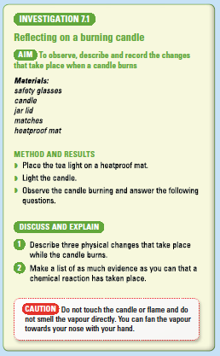

Observations

Physical Changes

•

•

•

Chemical Changes

•

•

•

